**Zomota restaurant clustering and sentiment analysis**

**Sundar K**

**Data science trainee**

**AlmaBetter**

|  |
| --- |
| **Contents** |

|  |  |
| --- | --- |
| **1.** | **Introduction** |
| **2.** | **Problem Statement** |
| **3.** | **Data Description** |
| **4.** | **Data Features** |
| **5.** | **Steps Involved** |
| **6.** | **Algorithms** |
| **7.** | **Model Performance** |
| **8.** | **Clustering** |
| **9.** | **Conclusion** |
| **10.** | **Reference** |

1. **Introduction**

Zomato is an Indian restaurant aggregator and food delivery start-up founded by Deepinder Goyal and Pankaj Chaddah in 2008. Zomato provides information, menus and user-reviews of restaurants, and also has food delivery options from partner restaurants in select cities.

India is quite famous for its diverse multi cuisine available in a large number of restaurants and hotel resorts, which is reminiscent of unity in diversity. Restaurant business in India is always evolving. More Indians are warming up to the idea of eating restaurant food whether by dining outside or getting food delivered. The growing number of restaurants in every state of India has been a motivation to inspect the data to get some insights, interesting facts and figures about the Indian food industry in each city. So, this project focuses on analysing the Zomato restaurant data for each city in India

1. **Problem Statement**

The Project focuses on Customers and Company, you have to analyze the sentiments of the reviews given by the customer in the data and made some useful conclusion in the form of Visualizations. Also, cluster the zomato restaurants into different segments. The data is vizualized as it becomes easy to analyse data at instant. The Analysis also solve some of the business cases that can directly help the customers finding the Best restaurant in their locality and for the company to grow up and work on the fields they are currently lagging in.

This could help in clustering the restaurants into segments. Also data has valuable information around cuisine and costing which can be used in cost vs. benefit analysis

Data could be used for sentiment analysis. Also the metadata of reviewers can be used for identifying the critics in the industry.

1. **Data Description**

**Zomoto Restaurant names and Metadata**

1. Name : Name of Restaurants

2. Links : URL Links of Restaurants

3. Cost : Per person estimated Cost of dining

4. Collection : Tagging of Restaurants w.r.t. Zomato categories

5. Cuisines : Cuisines served by Restaurants

6. Timings : Restaurant Timings

**Zomato Restaurant Reviews**

1.Restaurant : Name of the Restaurant

2. Reviewer : Name of the Reviewer

3. Review : Review Text

4. Rating : Rating Provided by Reviewer

5. MetaData : Reviewer Metadata - No. of Reviews and followers

6. Time: Date and Time of Review

7. Pictures : No. of pictures posted with review

1. **Data Features**

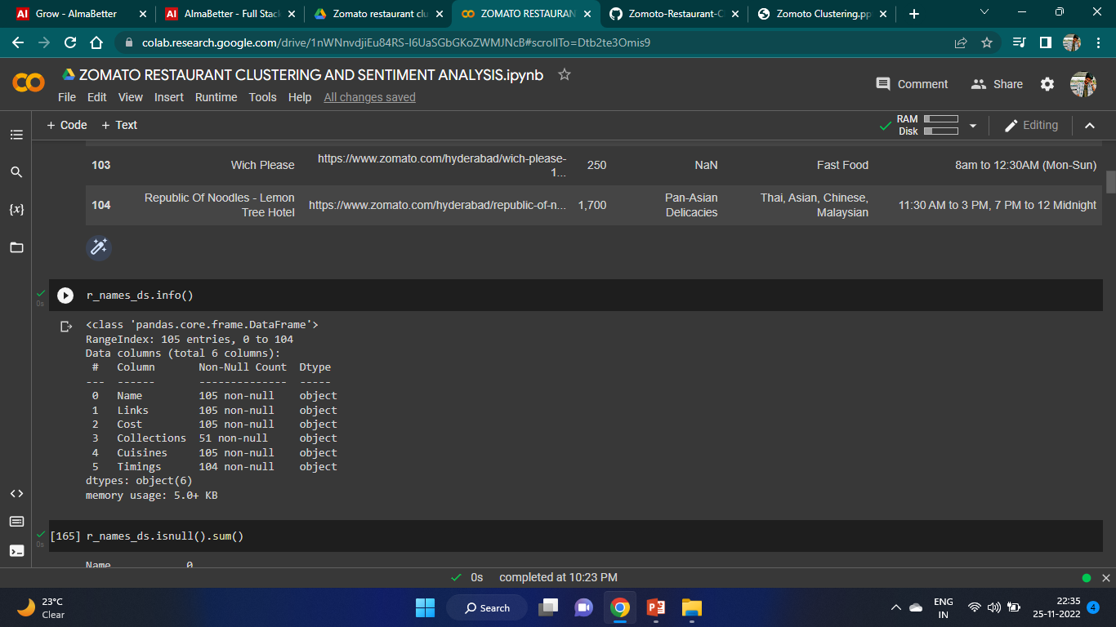

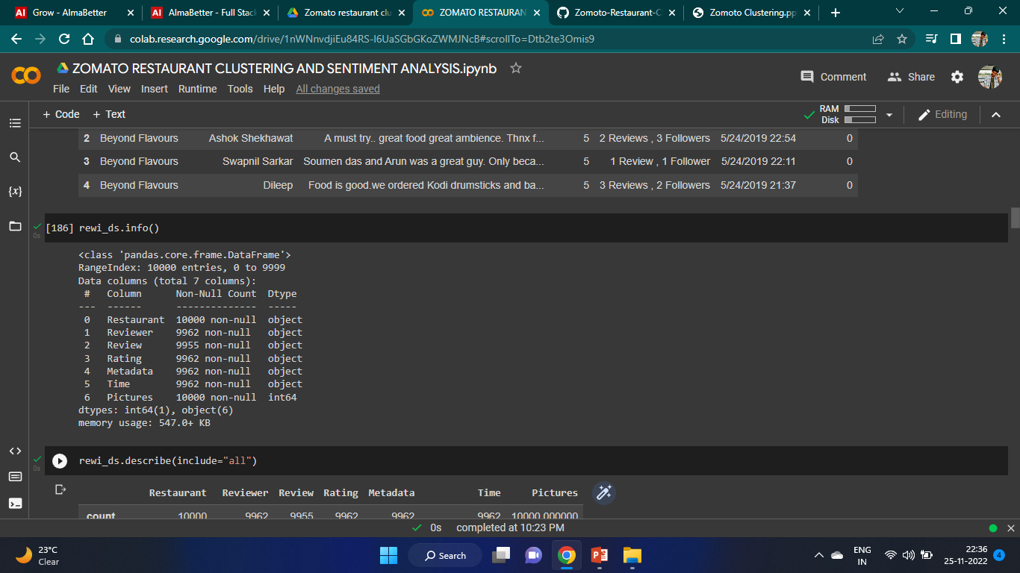

1. **Steps Involved**

* **Exploratory Data Analysis**

After loading the dataset we performed this method. This process helped us figuring out various aspects and relationships among the target and the independent variables. It gave us a better idea of which feature behaves in which manner compared to the target variable.

* **Null values Treatment**

Our dataset contains a large number of null values which might tend to disturb our accuracy hence we dropped them at the beginning of our project inorder to get a better result.

* **Standardization of features**

Our main motive through this step was to scale our data into a uniform format that would allow us to utilize the data in a better way while performing fitting and applying different algorithms to it.

The basic goal was to enforce a level of consistency or uniformity to certain practices or operations within the selected environment.

* **Fitting different models**

For modelling we tried various classification algorithms like:

1. **Support Vector Machine**
2. **Random Forest Classifier**
3. **XGB**
4. **Algorithms**

**Support Vector Machine**

SVM is used mostly when the data cannot be linearly separated by logistic regression and the data has noise. This can be done by separating the data with a hyperplane at a higher order dimension.

In SVM we use the optimization algorithm as:

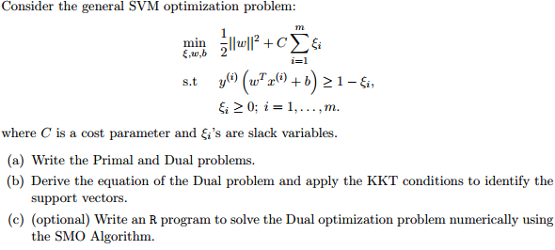

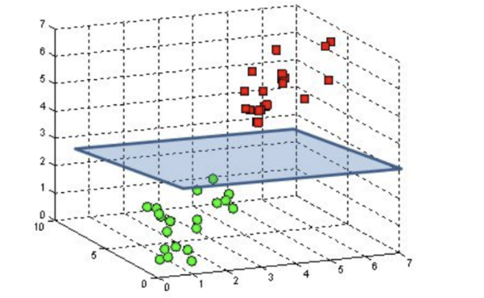

We use hinge loss to deal with the noise when the data isn’t linearly separable.

Kernel functions can be used to map data to higher dimensions when there is inherent non linearity.

**Random Forest Classifier:**

Random Forest is a bagging type of Decision Tree Algorithm that creates a number of decision trees from a randomly selected subset of the training set, collects the labels from these subsets and then averages the final prediction depending on the most number of times a label has been predicted out of all.

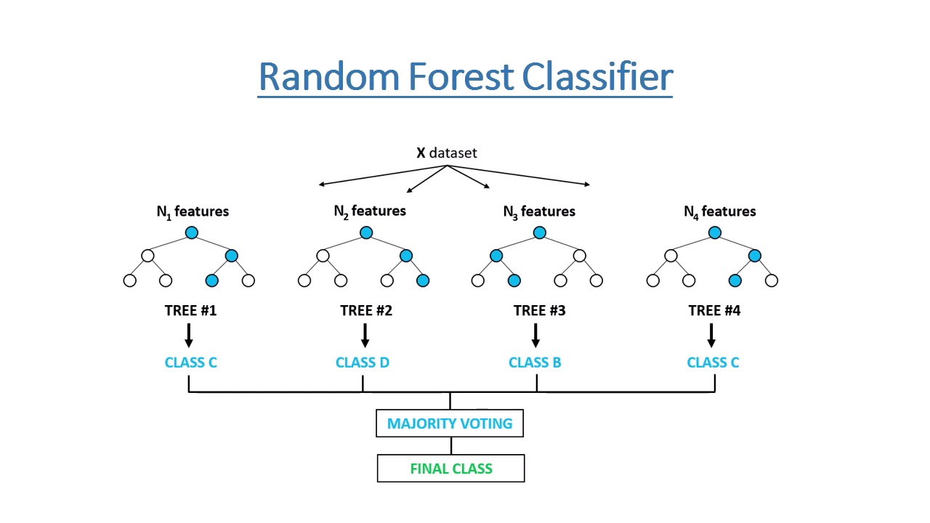

**XGBoost-**

To understand XGBoost we have to know gradient boosting beforehand.

* **Gradient Boosting-**

Gradient boosted trees consider the special case where the simple model is a decision tree

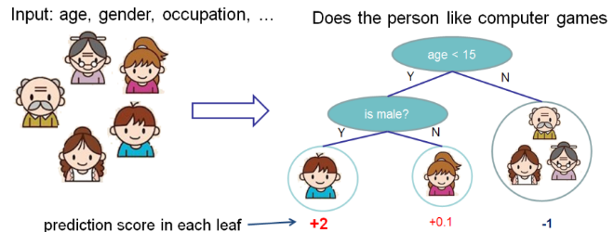

In this case, there are going to be 2 kinds of parameters P: the weights at each leaf, w, and the number of leaves T in each tree (so that in the above example, T=3 and w=[2, 0.1, -1]).

When building a decision tree, a challenge is to decide how to split a current leaf. For instance, in the above image, how could I add another layer to the (age > 15) leaf? A ‘greedy’ way to do this is to consider every possible split on the remaining features (so, gender and occupation), and calculate the new loss for each split; you could then pick the tree which most reduces your loss.

**XGBoost** is one of the fastest implementations of gradient boosting. trees. It does this by tackling one of the major inefficiencies of gradient boosted trees: considering the potential loss for all possible splits to create a new branch (especially if you consider the case where there are thousands of features, and therefore thousands of possible splits). XGBoost tackles this inefficiency by looking at the distribution of features across all data points in a leaf and using this information to reduce the search space of possible feature splits.

1. **Model Performance**

Model can be evaluated by various metrics such as:

**Confusion Matrix**-

The confusion matrix is a table that summarizes how successful the classification modelis at predicting examples belonging to various classes. One axis of the confusion matrix is the label that the model predicted, and the other axis is the actual label.

**Precision/Recall**-

Precision is the ratio of correct positive predictions to the overall number of positive predictions : TP/TP+FP

Recall is the ratio of correct positive predictions to the overall number of positive examples in the set: TP/FN+TP

**Accuracy**-

Accuracy is given by the number of correctly classified examples divided by the total number

of classified examples. In terms of the confusion matrix, it is given by: TP+TN/TP+TN+FP+FN

1. **Clustering** 
   * + 1. K-Means Clustering
       2. PCA Principle Components Analysis

**K-Means Clustering**

K-Means Clustering is an unsupervised learning algorithm that is used to solve the clustering problems in machine learning or data science. The K-means clustering algorithm computes centroids and repeats until the optimal centroid is found. It is presumptively known how many clusters there are. It is also known as the flat clustering algorithm. The number of clusters found from data by the method is denoted by the letter ‘K’ in K-means.

In this method, data points are assigned to clusters in such a way that the sum of the squared distances between the data points and the centroid is as small as possible. It is essential to note that reduced diversity within clusters leads to more identical data points within the same cluster.

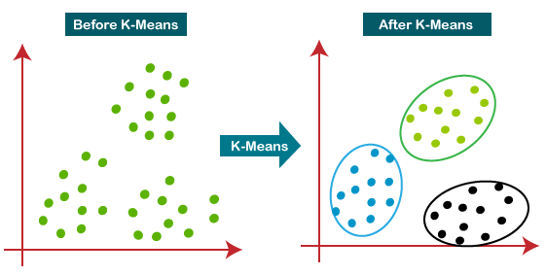

**Principle Components Analysis**

Principal Component Analysis (PCA) is a statistical procedure that uses an orthogonal transformation that converts a set of correlated variables to a set of uncorrelated variables. PCA is the most widely used tool in exploratory data analysis and in machine learning for predictive models. Moreover, PCA is an unsupervised statistical technique used to examine the interrelations among a set of variance

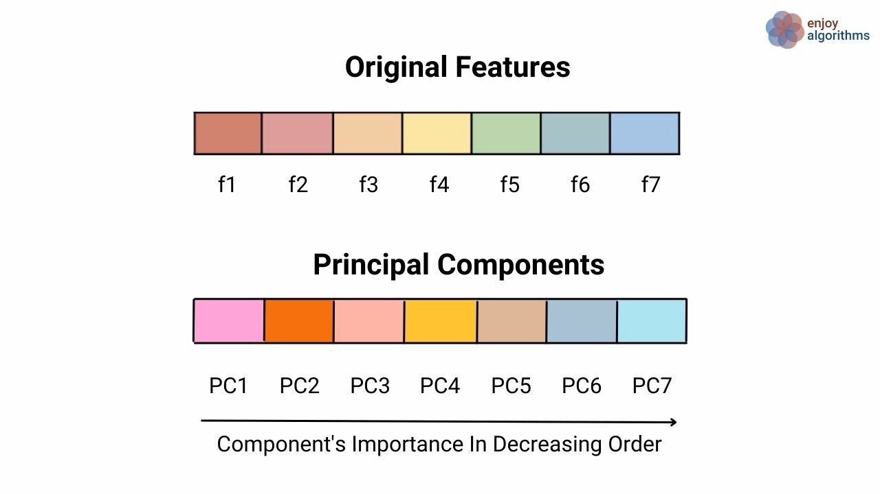

1. **Conclusion**

The most popular cuisines are the cuisines which most of the restaurants are willing to provide. The most popular cuisines in Hyderabad are North Indian, Chinese, Continental, and Hyderabadi. Sentiment Analysis was done on the reviews and a model was trained in order to identify negative and positive sentiments.   
SVM and XGB both performed well and we can choose any one them,SVM and XGB are having 0.921 and 0.981 of testing accuracy respectively.  
 We got best cluster as 5 in K-Means and Principal Component Analysis(PCA).

**10.Reference**

● Machine Learning Mastery

● GeeksforGeeks

● Analytics Vidhya Blogs

● Towards Data Science Blogs

● Built in Data Science Blogs

● Scikit- Learn Org